**COIT20248: Information Systems Analysis and Design**

**Term 2, 2019**

**Assessment 1 - Systems Development**

Lecturer: Sanjay Jha

Tutor: Sanjay Jha

Prepared by:

Student Name Bishal Budhathoki

Student Number 12116421

Table of Contents

1. Introduction 1
   1. Project Aims 1
   2. Project Objectives 1
2. Approach to Systems Development 1
3. Systems Requirements 2
   1. Functional Requirements 3
   2. Non-functional Requirements 3
4. Project Cost-Benefit Analysis 4
5. Project Schedule 5
   1. Work Breakdown Structure (WBS) 6
   2. Gantt Chart 7
6. System Information Investigation Techniques 9
   1. Stakeholders: 9
      1. Internal Stakeholders: 9
      2. External Stakeholders: 9
   2. Investigation Techniques: 9
      1. Interviews: 9
      2. Past Document Analysing: 10
      3. Questionaries: 10
7. Reflections and Conclusions 10
8. References 10
9. **Introduction**  
   Repair-Made-Easy is a one way stop to wide range of computers spare parts and services which consist of desktops and notebooks which has its store in Melbourne, Australia. One can buy parts and repair their system themselves, or one can take in their system in for repair where they should pay for parts and labour service charge. At the moment, RME works manually, unsynchronised, time consumingly and on non-transparent PC-based Excel Spreadsheets.
   1. **Project Aims**

The aim of the project is to design and develop a modern and highly effective information system to replace the manual system and its associated spreadsheets.

The RME have few of the requirements for their system which are:

* Developed information system must be web-based so that business can be expanded in the future via Internet in different stores
* Implement centralised database system to update every customer, supplier and business data
  1. **Project Objectives**

The following are the list of well-formed project objectives that has been set in order to achieve the project aims in the development of the web-based RME Information System.

1. Identify the best approach for system development.

2. Analyse the impact of new RME Information System in the existing business process

3. Perform the cost-benefit analysis.

4. Obtain all the functional requirements of the system.

5. Perform Work Breakdown structure in order in order to finish the project on deadline.

1. **Approaches to Systems Development**

Two ways of software development are adaptive and predictive method (Elisa W 2005). The predictive method is worth for the projects that have clear objectives to do whereas adaptive method is for the unclear, uncertain objectives one. According to Elisa W (2005), predictive approach sets a linear continuous path for software development with a specific deadline but adaptive method disintegrate project into chunks and has uncertain output at the end. Predictive method consists of Waterfall Model while agile methodologies like RAD, JAD, etc are of adaptive method.

On completion of Requirement analysis, adaptive method using Agile approach seems suitable for developing RME Information System as it not only makes project finish quick but can be rollback to various required phases during the development of project. This approach is also worth for web-based application system as changes can and should be done at certain time.

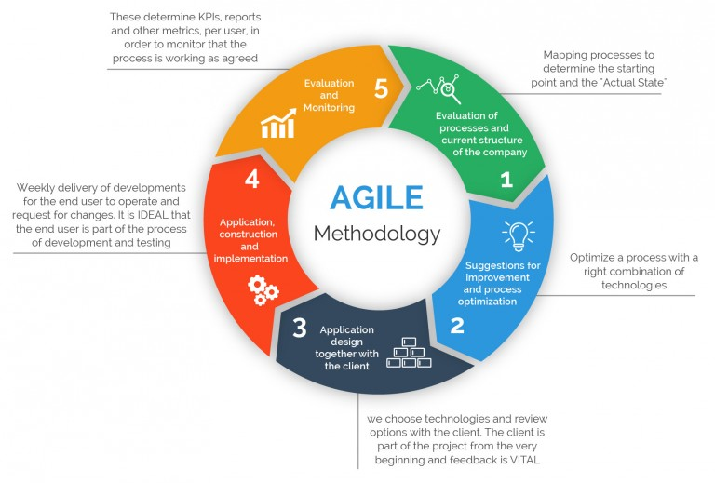

**Figure 2.1: Agile Methodology**

**Source: 360Logica**

This methodology is appropriate for this IS as it has: (Source: Schwaber, K (2004))

1. Constant integration, verification and validation of rising product.
2. issues and defects of the merchandise is well discovered.
3. Frequent demonstration of reach to increase the chance that the end product can satisfy requirements of the customers.
4. Ability to vary dynamically to the customers desires and wishes wherever options are largely focused.
5. **Systems Requirements:**

As per Inflectra (2018), system requirements are all the capabilities that a required system is meant to do. Web-based Management System (WMS) requirement is to develop a core system to handle all business data related to RME. RME Information System have functional and non-functional requirements.

* 1. **Functional Requirements:**

It states the functionality or behaviour of system (UIF E 2012).

1. **Super Admin Module:**

* Can add or remove staffs, customers and suppliers record
* Can keep record of inventory and sales, shipments of products
* Can add new store and other functions when needed.

1. **Store Admin Module:**

* Can handle store data
* Can arrange accounts of sales in store
* Can handle stocks of products

1. **Sales Module:**

* Can maintain sales record of all stores
* Manage sales order and their history log

1. **Supplier Module:**

* Keeps tracks of orders and their shipments
* Payments and their due date and maintain reminders

1. **Customer Module:**

* Can manage individual profile, orders, and invoice
* Keep track of products and book appointment for the services.
  1. **Non-functional Requirements:**

It defines how system behaves and involves the attributes of the system (UIF E 2012).

* Sent invoice to customers in any means
* Provide notification of new order made by RME and also the customers
* Provide details on stocks left in inventory
* User Friendly UI of system
* Login system for customers which are highly secured

1. **Project Cost/Benefit Analysis:**

Cost-Benefit Analysis is a very huge steps in project development that provide projects benefit, cost to spend and other various approaches. It helps in taking decision where either to continue or abort (Shelly &amp; Rosenblatt 2012). One-time cost is the amount from start of the project to development. The cost that keeps on going for the project is recurring cost (Valacich, George &amp; Hoffer, 2012).

|  |  |  |
| --- | --- | --- |
| **One-Time Cost Worksheet of Web based Information System** | | |
| **S. N** | **PARAMETER** | **COST** |
| 1. | Staff Cost | $ 150,000.00 |
| 2. | New Hardware | $ 300,000.00 |
| 3. | User Training | $ 75,000.00 |
|  | Total Development Cost | $ 525,000.00 |

|  |  |  |
| --- | --- | --- |
| **Recurring Cost of New Web based Information System** | | |
| **S. N** | **PARAMETER** | **COST** |
| 1. | Cloud Storage | $ 2,000.00 |
| 2. | Maintenance | $ 10,000.00 |
| 3. | (Others) Rent, Electricity, Internet | $ 2,000.00 |
|  | Total | $ 14,000.00 |

Total budget assigned for this project is $800,000 which comprises of development, training and other costs. The discount percentage is 6% annually and has a one-time cost of around $525,000 and recurring cost of $14,000.

The given excel-sheet provides the cost-benefit analysis of new WMS. The sheet calculation shows that Net Profit Value (NPV) is positive and break-even point befalls in between year 3 and 4. Total NPV in 5 years is $410,144.76. This cost-benefit analysis visualise that this project is economically feasible. So, it can be initiated and developed.

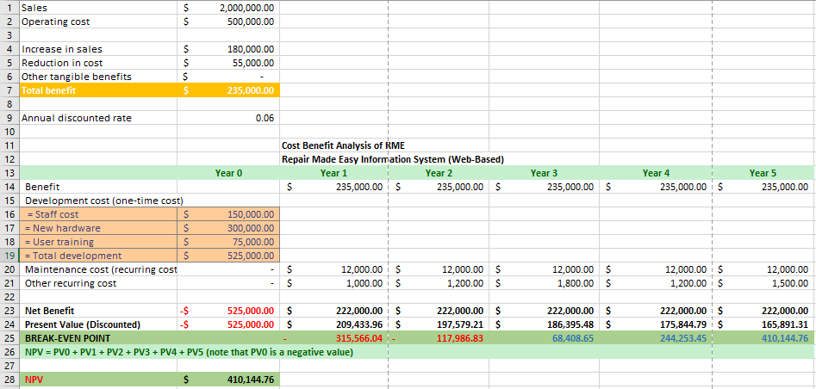

Figure 4.1: Cost-Benefit Analysis of RME Information System

The performance of RME peaks and helps in decreasing the cost in staff, processing time and increases productivity with the new web-based Information system for RME. Some of the intangible benefits are customer value gain, better control over business, improved organisational transparency and responsibility, etc.

1. **Project Management and Scheduling:**

Project schedule is a process to perform task that need to be get done and which resources of organisation will be used to complete those tasks in what frame (Stephaine 2017).

The following diagram illustrates the project scheduling of Web-Based RME Information System:

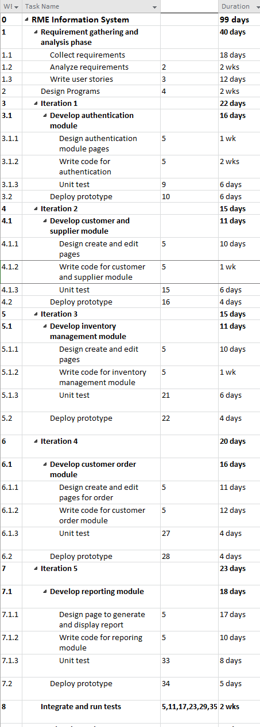

Figure 5: Project Schedule of RME Information System

* 1. **Work Breakdown Structure (WBS):**

WBS provides scope of the project and helps in changes that might occur during development phase.

The following diagram shows the WBS of RME Information System:

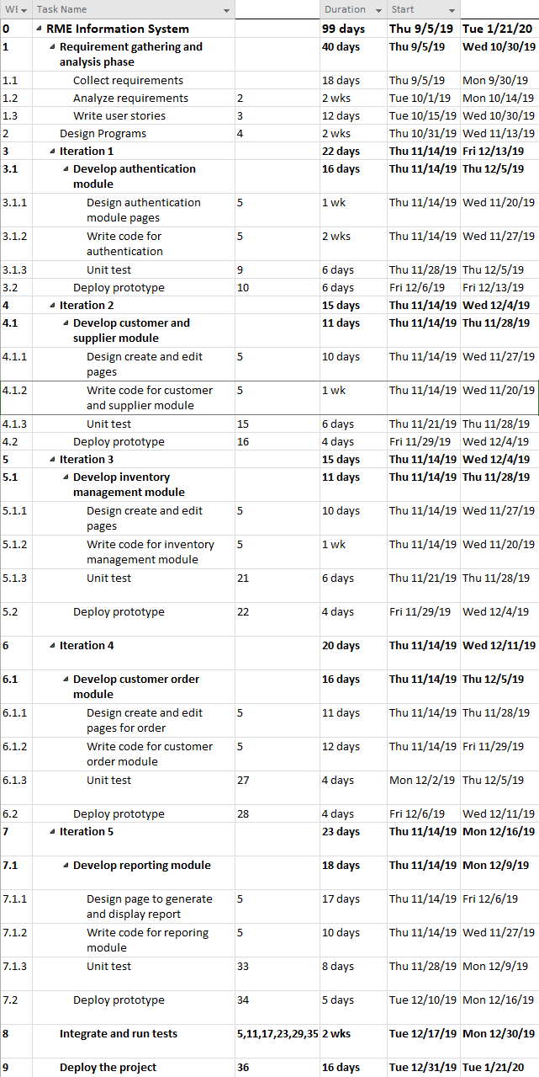

Figure 5.1: Work-Breakdown Structure of RME Information System

* 1. **Gantt Chart:**

Gantt chart is a graphical representation of tasks scheduled and represents timeline of tasks scheduled with start and end dates (Nishadha 2018).

The following diagram represents Gantt chart for RME Information System:

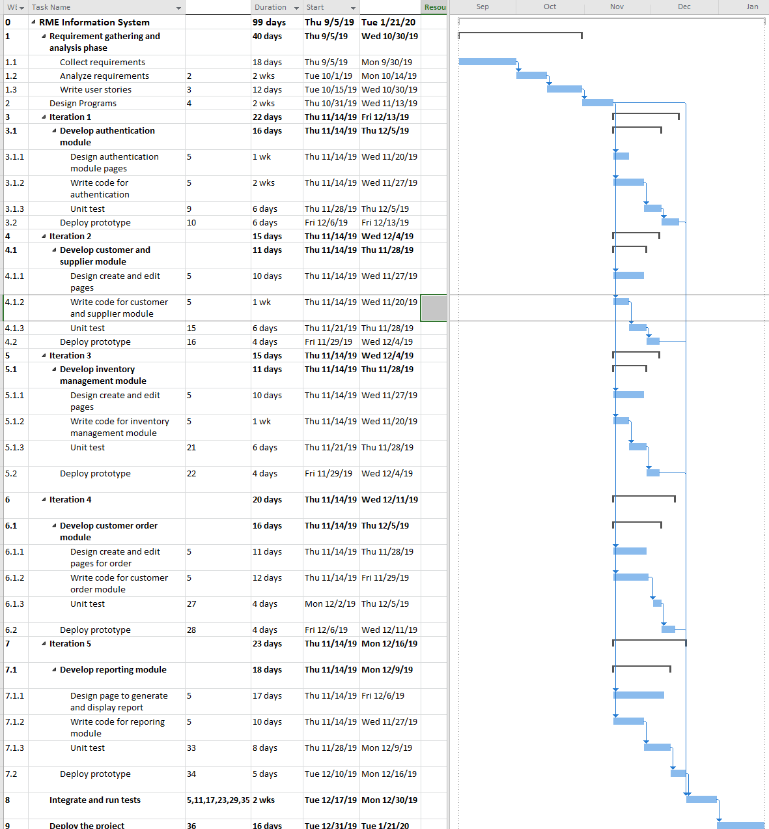

Figure 5.2: Gantt Chart of RME Information System

As from above, the Gantt chart is related with WBS Diagram and Project Schedule Diagram. As we can see, RME Information System has only few fixed requirements and mostly dynamic requirements, the project requirement and analysis phase can be done in 40 days. We can design programs in 2 weeks

From above Gantt chart, the project completion is in 99 days. It also represents predecessor value in predecessor column. By considering all the data, the project schedule is reasonable to initiate.

**6. System Information Investigation Techniques:**

**6.1 Stakeholders:**

Stakeholders are the person who are directly or indirectly connected with the business process (Peter L 2017). There are 2 types of stakeholders which are:

**6.1.1 Internal Stakeholder:**

The one who are concerned with internal business of institution are internal stakeholders (Lumencandela). Web-based RME Information System has following internal stakeholders:

* **Project Manager:**

Is responsible for managing the whole project and also acts as a communication medium between project developer team and the client.

* **Software Developer/Programmer:**

Hold liable for the development of the project, for backends and GUI for the application.

* **Tester:**

For testing the integrity of the application system and helps find possible bugs.

**6.1.2 External Stakeholder:**

The one who are not directly concerned with the internal business but are affected by its performance are external Stakeholder. Some of them are:

* **RME Management Team:**

This team is the primary stakeholder from client side as they are the owner of this application. This team looks for the implementation and completion of the project.

* **RME Staff/Customers/Suppliers using IS:**

These are the people that will be using the application the most for daily activities related to RME. This application will store data and business transactions related to RME.

**6.2 Investigation Techniques:**

It is the way of collecting information and data required for the project development and completion. Some techniques used in RME Information System are:

**6.2.1 Interviews:**

It is one of the most important and effective way of gathering information about the required system (Susan E 2014). Some of the benefits are:

* More precise information collection
* Keep track of progress

**6.2.2 Past Documents Analysing:**

This is one primary investigation procedure where old experiences and documents are looked after. This helps organisation to avoid past mistakes and move in a steady path of development. Resources and time are also saved here.

**6.2.3 Questionaries:**

Here, group of oral or written questions are answered by the respondent (Stefan D 2019). In RME IS, questionnaire gives following advantage:

* Not expensive process to collect data for RME Information System
* Maximum data in few times collected

**6.3 Usefulness of these 3 Investigation Techniques:**

* Provides opportunity for less mistakes or errors from past experiences.
* Experience of the past work help the project manager and other team members.
* Highly focused on stakeholders for the requirements.
* Help obtain time and cost of the project competition.
* Interviews provides feedbacks for improvements.

**7. Reflection and Conclusion:**

RME Information System is a web-based automated system that manages all the manual spreadsheets of all logs related to buying, orders, suppliers and all. Now with this project RME can manage their stores across any location, staffs and customers more systematically as all their data are integrated in a centralised system.

In conclusion, the new RME Information system will solve the existing problem of Repair-Made-Easy by shifting manual tasks to automated. And also, the hectic work on filling spreadsheet, integrating them according to required needs is now gone. Agile method has been selected for this project development. This project is financially feasible as it has positive NPV value, payback period of 3 – 4 years and is estimated to complete for 99 days which can be finished on time.

**8. References:**

Susan E 2014, ​Advantages and Disadvantages of Face-to-Face Data Collection, viewed 17 April 2019,

<https://www.snapsurveys.com/blog/advantages-disadvantages-facetoface-data-collection/>

Stephaine 2017, ​What Is Project Scheduling? , viewed 18 April 2019, <https://www.projectmanager.com/blog/what-is-project-scheduling>

Peter L 2017, ​What is a Stakeholder? ​, viewed 18 April 2019,

<https://www.projectmanager.com/blog/what-is-a-stakeholder>

Lumencandela , ​Overview of Key Elements of the Business ​ , viewed 16 April 2019, <https://courses.lumenlearning.com/boundless-accounting/chapter/overview-of-key-elements-of-the-business/>

Inflectra 2019, ​What are System Requirements Specifications/Software (SRS)? ​, viewed 14 April 2019,​ <https://www.inflectra.com/ideas/topic/requirements-definition.aspx>

Ulf E 2012, ​Functional vs Non Functional Requirements ​ , viewed 14 April 2019, <https://reqtest.com/requirements-blog/functional-vs-non-functional-requirements/>

Elisa W, ​Adaptive vs. Predictive: Is the end clear? , viewed 14 April 2019, <http://www.idea.org/blog/2005/12/02/adaptive-vs-predictive-is-the-end-clear/>

Valacich, J. George, J. Hopper, J. 2012, ​Essential of Systems Analysis and Design 5 Edition, Pearson, Prentice Hall.

Cobb, C.G., 2011. Agile Project Management. In Making Sense of Agile Project Management. Hoboken, NJ, USA: John Wiley & Sons, Inc., pp. 101–130.

Schwaber, K., 2004. Agile Project Management with Scrum, Redmond: Microsoft Press.

Lucidchart 2017, ​How to Create a Work Breakdown Structure and Why You Should, viewed 16 April 2019, https://www.lucidchart.com/blog/how-to-create-a-work-breakdown-structure-and-why-yo u-should

THANK-YOU